Experiment 2: Creating and Publishing an Online Lab Manual

Lab Tasks:

1. Create a lab2.html file as the homepage of your online lab manual.

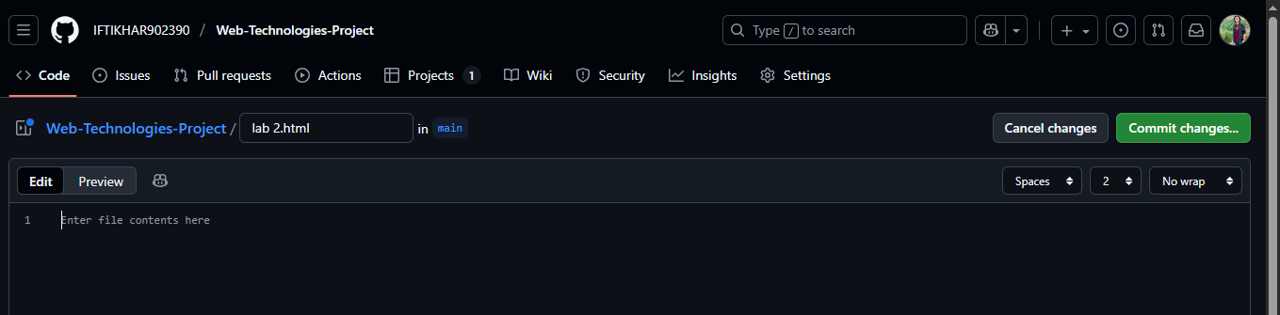

1. Insert a hyperlink to your lab1.html file.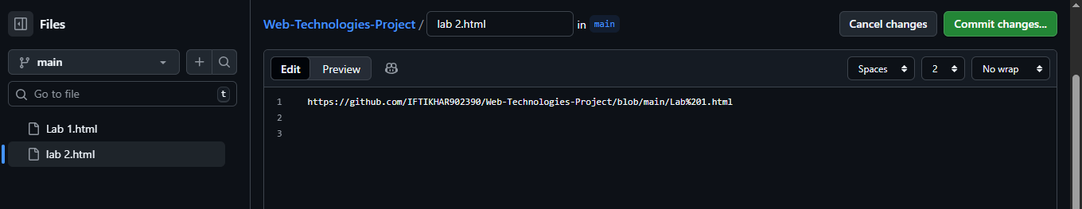
2. Add images/screenshots showing your GitHub Pages site.

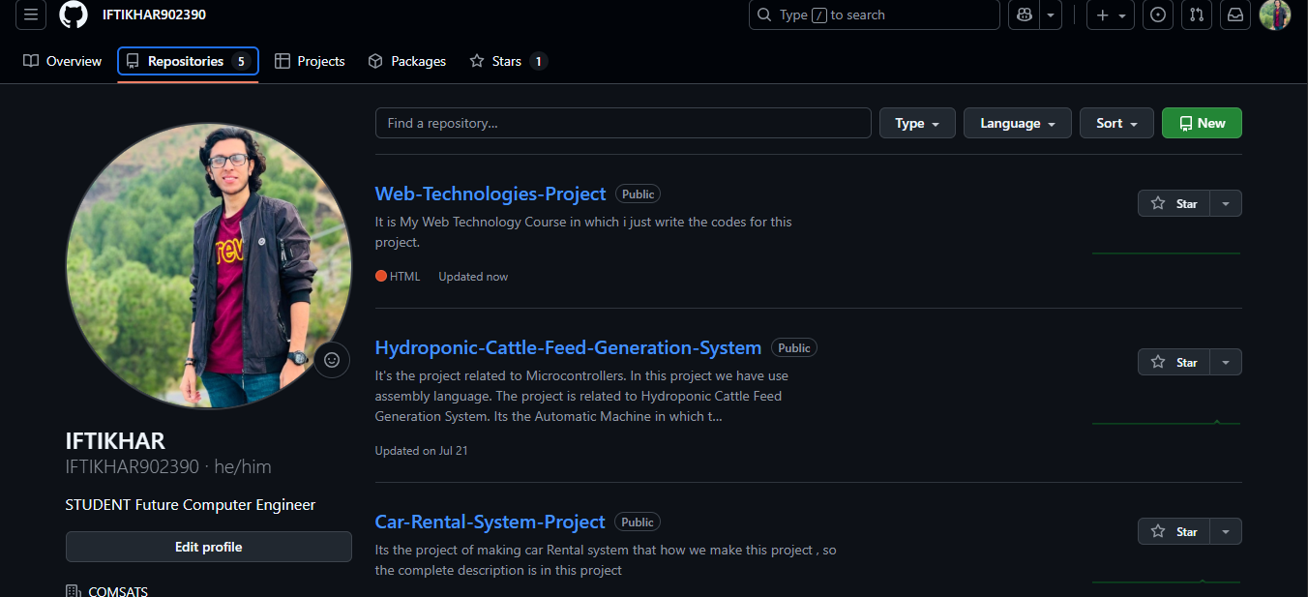

1. Upload both lab1.html and lab2.html to a new GitHub repository.

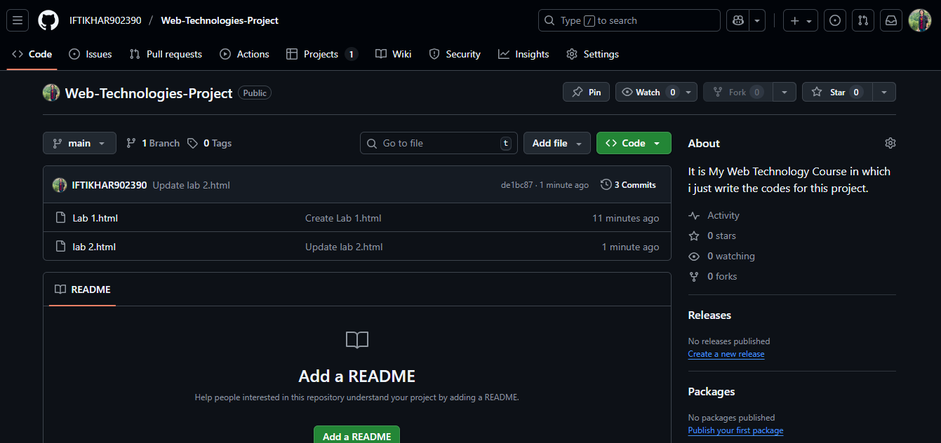

1. Enable GitHub Pages and obtain the live link

<https://github.com/IFTIKHAR902390/Web-Technologies-Project>

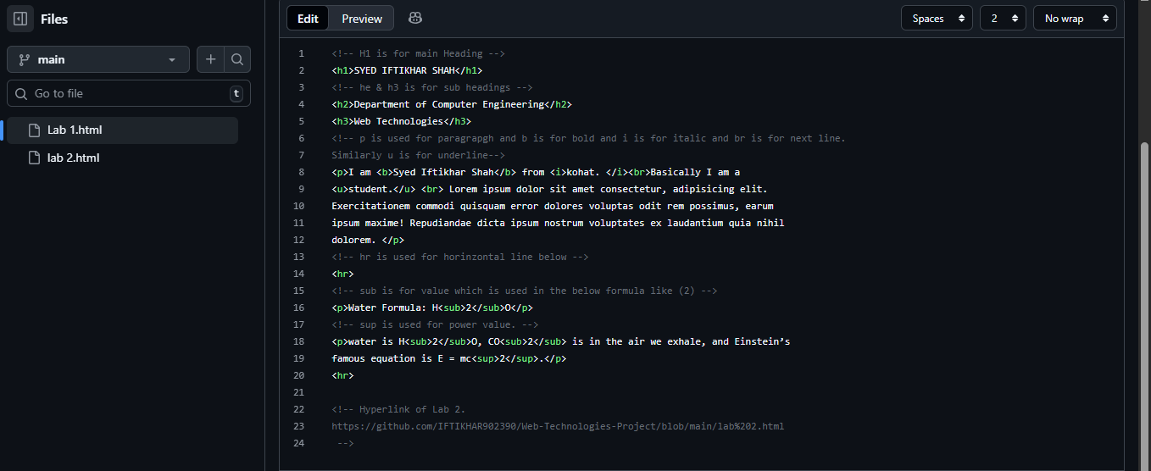

1. Share the public GitHub Pages link with your instructor using CUONLINE.